#help(resid)

regressor.lm = lm(formula = Salary ~ YearsExperience,

data = Salary_Data)

regressor.res= resid(regressor.lm)#residual

eruption.stdres = rstandard(regressor.lm)#standard residual

Standardized Residual =----------Residual-----------
                       Standard Deviation of Residual


plot(Salary_Data$YearsExperience, eruption.stdres,

ylab="Residuals", xlab="YearsExperience",

main="Salary_Data")

abline(0, 0) # the horizon

#The residual data of the simple linear regression model is the difference between the observed data of the dependent variable y and the fitted values y.

#Residual = y- ^y

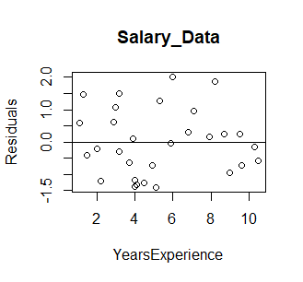standard residual

QQPLOT

qqnorm(regressor.stdres,

ylab="Standardized Residuals",

xlab="Normal Scores",

main="Old Faithful Eruptions")

qqline(regressor.stdres)

